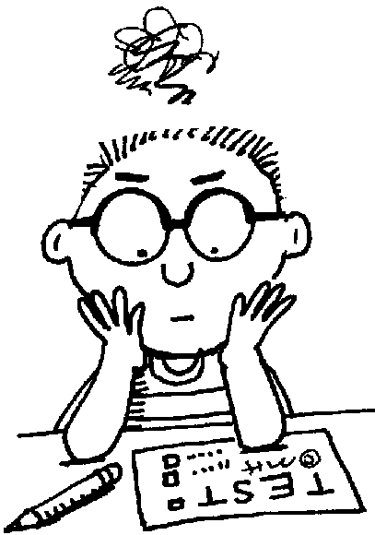
Not All Lessons are Created Equal

 | National Park  Geocaching Lesson | Geoliteracy
Lesson Goal – What will students learn?

Levels of Thinking – Bloom’s, DOK, or other?

Scope of Lesson – What is the depth of the learning?

Connections to Common Core

