**Challenge Card One**

What is the relationship between degrees and distance for latitude and longitude?

Why is this the case?

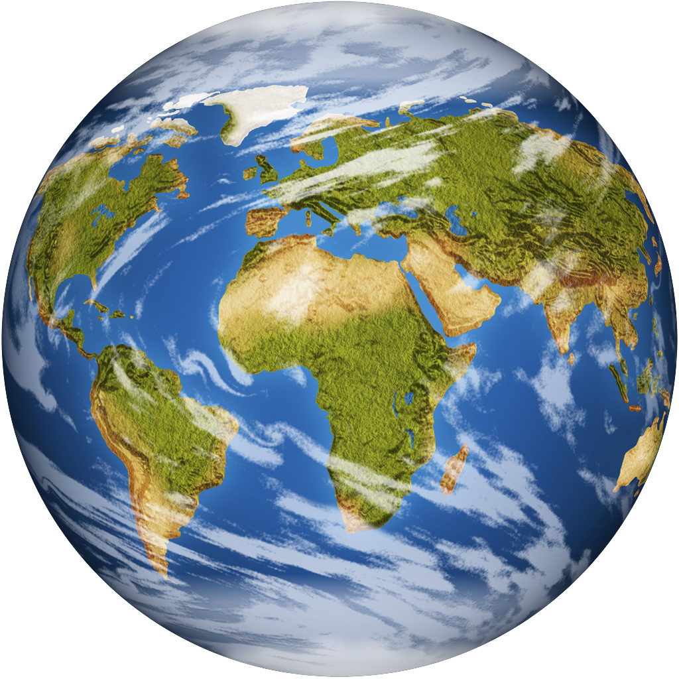

**Challenge Card Two**

When you geocache here in St. Charles,

about how far is a degree, minute, and

second for latitude and longitude?

